**Reference Diagram**

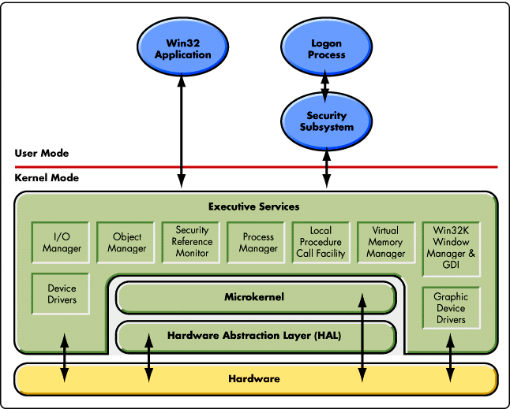

**Student Questions**

1. What is a device driver?
   1. Provide a brief summary

A device driver is a software [program](https://searchsoftwarequality.techtarget.com/definition/program) that controls a particular type of hardware [device](https://whatis.techtarget.com/definition/device) that is attached to a computer. many device drivers are built into the product. However, if a user later buys a new type of device that the operating system did not anticipate, the new device driver will have to be installed. A device driver essentially allows smooth communication between a connected hardware device and the operating system ([OS](https://whatis.techtarget.com/definition/operating-system-OS)).

* 1. List some devices that require a device driver.

Hardware that uses a device driver to connect to a computer include printers, displays, CD-ROM readers, network or sound cards, computer mice or hard disks

* 1. Provide a label on the reference diagram for the location of a device driver for your graphics card.

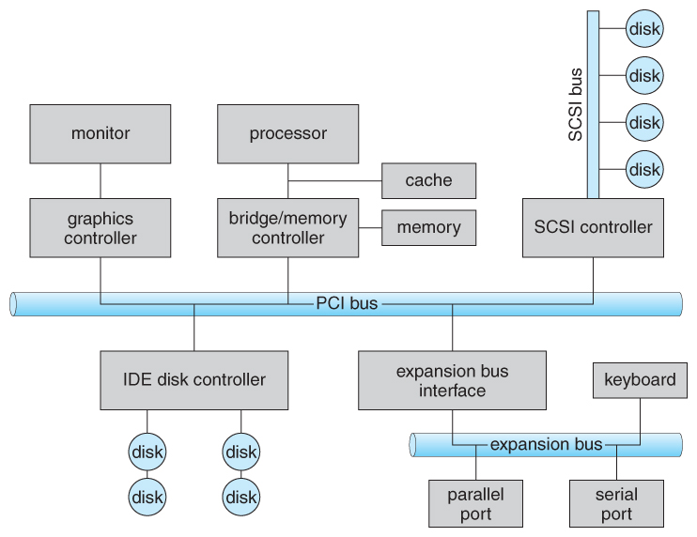

* 1. Provide a label on the reference diagram for the location of a device driver for a locally attached printer.

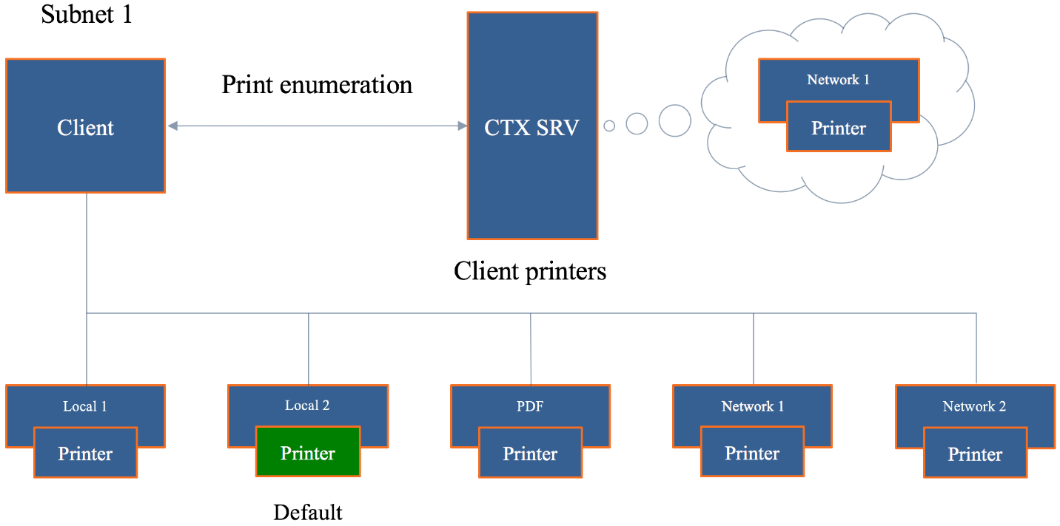

1. What is a DLL?
   1. Provide a brief summary

DLL files are nothing more than a means for developers to use shared code and data, allowing to upgrade functionalities without the need to re-link or re-compile applications. In other words, DLL files contain code and data that is used by several different applications

* 1. Explain how DLLs are related to user application programs

DLL’s store information or code as the same thing as user application programs

* 1. Provide a label on the reference diagram for the location of a DLL

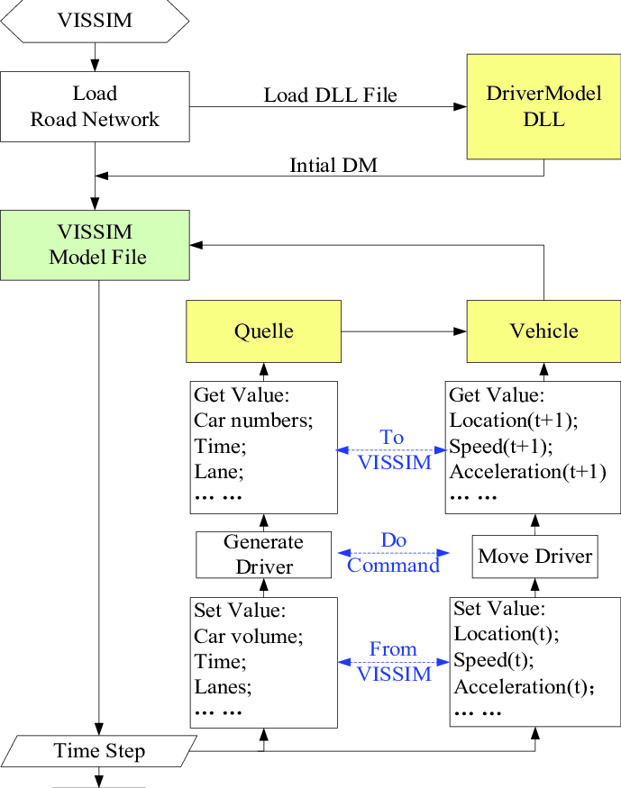

1. What is a windows manager?
   1. Provide a brief summary

Desktop Window Manager (dwm.exe) is a compositing window manager that renders all those pretty effects in Windows: transparent windows, live taskbar thumbnails, Flip3D, and even high resolution monitor support.

* 1. Explain how a windows manager is related to user application programs

A windows manager and a user application are related as they both process

* 1. Provide a label on the reference diagram for the location of a DLL

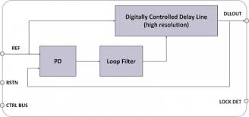

1. What is the windows task manager?
   1. Provide a brief summary

Windows Task Manager enables you to monitor the applications, processes, and services currently running on your PC. You can use Task Manager to start and stop programs and to stop processes, but in addition Task Manager will show you informative statistics about your computer's performance and about your network

* 1. List and explain four (4) types of system information provided by the task manager
* **Processes**: A list of running applications and background processes on your system along with CPU, memory, disk, network, GPU, and other resource usage information.
* **Performance**: Real-time graphs showing total CPU, memory, disk, network, and GPU resource usage for your system. You’ll find many other details here, too, from your computer’s [IP address](https://www.howtogeek.com/341307/how-do-ip-addresses-work/) to the model names of your computer’s CPU and GPU.
* **App History**: Information about how much CPU and network resources apps have used for your current user account. This only applies to new Universal Windows Platform (UWP) apps—in other words, [Store apps](https://www.howtogeek.com/243559/why-desktop-apps-arent-available-in-the-windows-store-yet/)—and not traditional Windows desktop apps (Win32 applications.)
* **Startup**: A list of your startup programs, which are the applications Windows automatically starts when you sign into your user account. You can disable startup programs from here, although you can also do that from Settings > Apps > Startup.
  1. Provide a label on the reference diagram for the operating system components related to each type of information.

